Best Location for Indian Residents/Visitors in Barcelona

# Introduction

## Background

Barcelona is one of the world's leading tourist, economic, trade fair and cultural centres, and its influence in commerce, education, entertainment, sports, media, fashion, science, and the arts all contribute to its status as one of the major global cities. In 2016 about 59% of the inhabitants of the city were born in Catalonia and 18.5% coming from the rest of the country. In addition to that, 22.5% of the population was born outside of Spain, a proportion which has more than doubled since 2001 and more than quintupled since 1996 when it was 8.6% respectively 3.9%.

## Problem

Since immigration has increased there are lots of Indians who travel there but they don’t know which location will be most suitable for them. We wish to find a good neighbourhood for living in the city which has good Indian restaurants and other places which might interest them.

## People Benefitted by the Project

People of Indian Origin who want to settle in Barcelona and people who are going there for long trips will be most benefitted. Also, tourist can use this to find neighbourhoods which will have quick access to Indian stores and veg food available. Vegetarian people are most benefitted as its difficult to find suitable food in such countries.

# Data Acquisition and Cleaning

Data is mostly collected from Four-square and web scraping.

List of Neighbourhoods will be collected using web Scraping the following link:

<https://en.wikipedia.org/wiki/Category:Neighbourhoods_of_Barcelona>

For each neighbourhood, we will use Geocoder Python to get its coordinate.

Venues from Four-Square will be used. Web scraping will be used for other data which isn’t available on FourSquare.

Data will be cleaned and organized then displayed in forms understandable to basic users.

Machine learning techniques will be used to classify and segment neighbourhoods.

We have used K-Means Method here for the sake of simplicity.

This will help decide which one is most suitable for the person’s needs.

# Observations and Discussions

### 3.1 We formed 6 clusters which group different areas based on types of venues-

Cluster 0 has 26 neighbourhoods

Cluster 1 has 1 neighbourhood

Cluster 2 has 38 neighbourhoods

Cluster 3 has 2 neighbourhoods

Cluster 4 has 1 neighbourhood

Cluster 5 has 8 neighbourhoods

### 3.2 Frequency of Venues in Various Selected Places were shown as-

**----Diagonal Mar i el Front Marítim del Poblenou----**

**venue freq**

**0 Mediterranean Restaurant 0.13**

**1 Restaurant 0.07**

**2 Italian Restaurant 0.04**

**3 Spanish Restaurant 0.04**

**4 Hotel 0.04**

**----El Congrés i els Indians----**

**venue freq**

**0 Tapas Restaurant 0.07**

**1 Bar 0.07**

**2 Grocery Store 0.07**

**3 Restaurant 0.06**

**4 Spanish Restaurant 0.05**

**----Les Tres Torres----**

**venue freq**

**0 Japanese Restaurant 0.07**

**1 Bakery 0.07**

**2 Mediterranean Restaurant 0.06**

**3 Restaurant 0.06**

**4 Spanish Restaurant 0.05**

**----Pedralbes----**

**venue freq**

**0 Park 0.11**

**1 Restaurant 0.07**

**2 Hotel 0.07**

**3 Mediterranean Restaurant 0.07**

**4 Café 0.07**

**----Sants----**

**venue freq**

**0 Mediterranean Restaurant 0.06**

**1 Tapas Restaurant 0.06**

**2 Restaurant 0.05**

**3 Spanish Restaurant 0.05**

**4 Hostel 0.04**

**----Sants-Badal----**

**venue freq**

**0 Tapas Restaurant 0.07**

**1 Pizza Place 0.06**

**2 Hostel 0.05**

**3 Bakery 0.04**

**4 Restaurant 0.04**

## 3.3 A map showing different clusters with each cluster in a different colour.

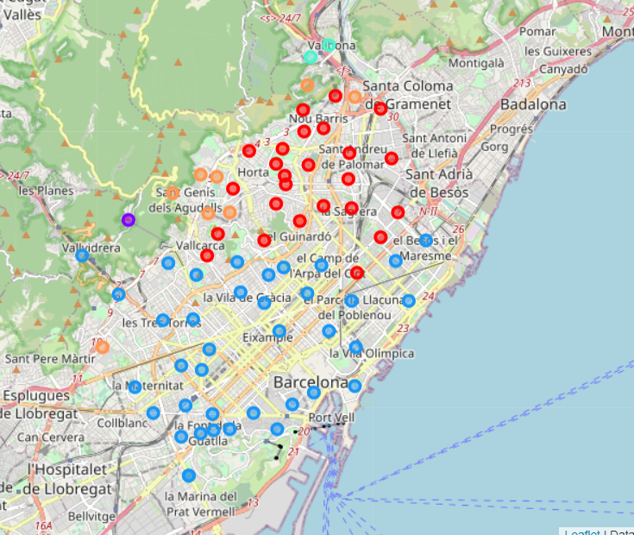

## 3.4 Points of Discussion

* As we have observed from the data showing frequency of venues, we can figure out type of area.
* We can know what kinds of location that would be and also find if Indian restaurants/Stores are in the vicinity.
* Bachelors who prefer hostels to stay can also find Areas with high number of hostels which also have a good nightlife.
* Families can look for areas with good number of parks and essential stores within 1km.

# Conclusion

So, after the analysis we have classified different areas based on Venues they have-

Basically, we identified different clusters

Cluster 5 is most suitable for families-

Pedralbes, Sant Genís dels Agudells, Torre Baró being the most suitable

Cluster 2 is most suitable for Bachelors -

Fort Pienc, Sants, Sants-Badal being the most suitable

General good places for living are - El Congrés i els Indians, Can Peguera, Bon Pastor, Sant Andreu de Palomar, Vallvidrera, La Guineueta

For Specific places with Indian Restaurants

Les Tres Torres, Diagonal Mar i el Front Marítim del Poblenou

# Limitations and Future Scope-

We need to incorporate more data to find what kind of population lives in what region.

Also, we haven’t considered distance from workplace in our program.

We can add these and few small more details to make this program more accurate and useful.

We can also expand this to make this useful for people of different religions, countries etc.

People will have to look manually for venues in a long list, we can maybe visualize it better in the future.